**Company:** BCG

**CEO:** Abhinaba Mukherjee

**Report Authors:** Sourav Sharma (211055), Vishal

**Chemical Formula:** C14H14O3

**Chemical Name:** (S)-6-Methoxy-α-methyl-2-naphthaleneacetic acid

**Use case:**

1. What is the use of this compound?

Naproxen is a nonsteroidal anti-inflammatory drug (NSAID) used to treat pain, inflammation, and stiffness caused by arthritis, menstrual cramps, and gout. It is also used to reduce fever. Naproxen works by preventing the body from producing certain natural substances that cause pain and inflammation.

1. Are there any alternatives to this compound? Name a few.

Yes, there are some alternatives, such as aspirin, ibuprofen, acetaminophen, and diclofenac.

1. Why this compound is superior to its alternatives?

Some studies have suggested that when compared to other NSAIDs such as diclofenac or ibuprofen, Naproxen may have a lower risk of certain adverse effects such as gastrointestinal bleeding and cardiovascular events.

1. Is this compound imported in India? What is the magnitude of imports?

Yes

**Economic feasibility:**

1. What input raw materials are needed for its synthesis (same as reported in the Patent application)?

Methoxy Naphthylene

Palladium(II) acetate

Triphenylphosphine

Sodium carbonate/NEt3

Br2/CH3COOH

Ethylene

N-alkyl Glucamine(work as chiral auxiliary)

Dioxan

1. Provide preliminary economic feasibility based on cost of raw materials, solvents and product selling price.

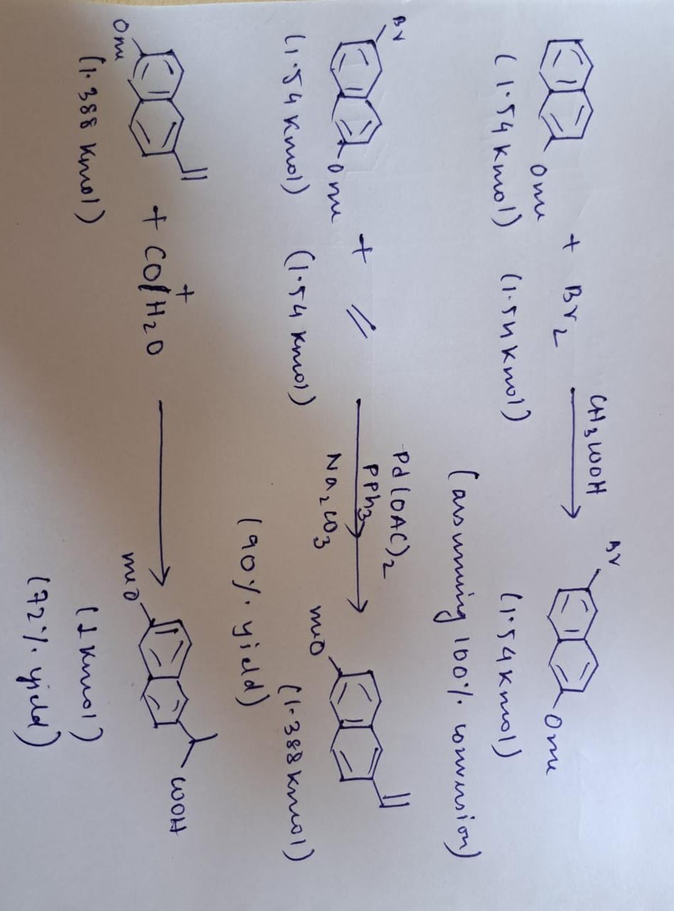

|  |  |  |  |  |
| --- | --- | --- | --- | --- |
| **Compound** | **Rate(in Rs/kg)** | **Rate(in Rs/Kmol)** | **Quantity(in Kmol)** | **Amount(in Rs)** |
| Methoxy Naphthylene | 7,400 | 11,70,680 | 1.54 | 18,02,847.20 |
| Palladium(II) acetate | 1,40,00,000 | ---- | Catalyst | Catalyst |
| Triphenylphosphine | 7,200 | 18,88,560 | Catalyst | Catalyst |
| Sodium carbonate | 40 | 4,240 | Catalyst | Catalyst |
| CH3COOH | 50 | 3,000 | Solvent | Solvent |
| Ethylene | 75 | 2,100 | 1.54 | 3,234 |
| Dioxane | 1,263 | 1,11,153 | Solvent | Solvent |
| Bromine gas | 300 | 47,700 | 0.77 | 36,729 |
| Naproxene | 29,600 | 68,08,000 | 1 | 68,08,000 |

Total input costs of raw materials for producing 1 kmol Naproxene

= Rs (11,70,680+2,100+47,700)=Rs 12,20,480

Assuming that for producing 1 kmol Naproxene 0.01 kmol of triphenylphospine and sodium carbonate and 0.1 kmol of acateic acid and dioxane to be used as balance input .

Total input cost for the solvents and catalyst

=Rs (0.01(7200+40) +0.1(1,11,153+3,000)) = Rs 11,487.7

**NET PROFIT IN PRODUCING 1 kmol NAPROXENE**

**=Rs(68,08,000-11,487.7-12,20,480)**

**=Rs 55,76,032**

**References:**

<https://www.srlchem.com/products/product/productId/142958/Palladium-II-Acetate-3375-31-3>

<https://srlchem.com/products/product_details/productId/1253/Triphenylphosphine-pure--98--603-35-0>

<https://dir.indiamart.com/impcat/soda-ash.html>

<https://dir.indiamart.com/impcat/acetic-acid.html>

<https://www.indiamart.com/proddetail/liquid-ethylene-19048817691.html>

<https://www.ottokemi.com/ir-spectroscopy-solvents/14-dioxan-spectroscopy.aspx>

**List the contributions of each author:**

* Akshat Jain and Sourav Sharma carried out the market research for chemical trade data.
* Vishal Vyavhare prepared the use case.
* Shivansh Maheshwari looked at economic feasibility.

**Sign the pdf and upload.**

|  |  |  |
| --- | --- | --- |
| Name | Roll No | Signature |
| CEO Name | 210028 |  |
| Akshat Jain | 210090 |  |
| Sourav Sharma | 211055 |  |
| Vishal Vyavhare | 211174 |  |
| Shivansh maheswari | 210987 |  |
| Fifth author Name, Roll No & signature (if any) |  |  |
| Sixth author Name (if any) |  |  |